INDONESIA: Advancing Indonesia’s Lighting Market to High Efficient Technologies (ADLIGHT)
Responses to GEFSec Comments 15 July 2019

Comments & Responses | Reference
1- On the executing arrangements: our comments made in July requested a clarification regarding the Executing functions (see screenshot below).
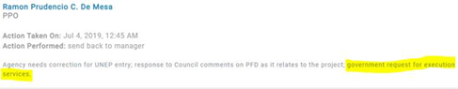
However in the ProDoc both –UNEP and UNDP— intend to carry out one executing activity which is “managing the funds” (see screenshot below)
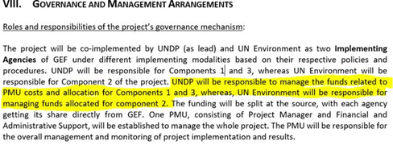

Response:  As stated in the GEF Guidelines on the Project and Program Cycle Policy, the project executing entity (EA) receives the project specific GEF funding from a GEF Agency. One of the responsibilities of the GEF Agency is therefore to foresee in the transfer of GEF funding to the EA on a quarterly basis. Funds are channeled through NIM quarterly Financial Advances against EA financial reports for the previous/completed quarter (FACE reports).  The oversight role of channeling funds through advancement of the funds on a quarterly basis following the NIM modality, has been explained in a footnote, added to the section referred to above (ProDoc page 77). In order to avoid any confusion, the word “managing” has been replaced by “channeling” in the ProDoc page 77. | ProDoc page 77, footnote added for additional clarification
Also the Agencies intend to carry out the executing function of committing or acquiring supplier resources required (see screenshot below)
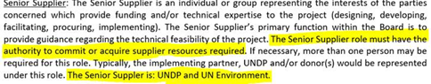

Response:  The section on composition of the Project Board has been revised and is now following the new arrangements as discussed between the GEF Secretariat and UNDP in 2019 in which it was agreed that UNDP would not take on the role of Senior Supplier. Please see revised text and Project Board structure in the ProDoc on page 77 and 78 (this project was developed in 2017/2018 and was not yet updated). | ProDoc page 77/78
Still the ProDoc mentions that the executing modality can consider UNDP providing project management cycle services if the Government of Indonesia request them (see screenshot below). Please ask the Agency to remove any mention to the possibility of carrying out executing services currently in the ProDoc.
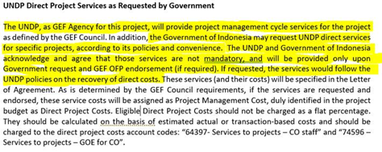

Response:  The section on UNDP Direct Project Services has been removed from the Project Document (page 84) since all Direct project Costs were removed from the project budget. | ProDoc page 84
While not mentioned in the previous review, it is hard to understand how a 3.8 million dollar project has a National Project Director and a Project Manager, both with similar functions (see screenshots below)
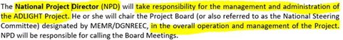
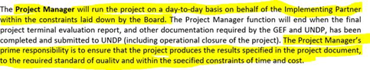

Response:  Text was added under Chapter 8 to explain that, using the established practice under NIM, the Government will designate a National Project Director (NPD) who will be nominated by MEMR. The NPD will provide up to 50% of his/her time, and be responsible for the overall direction, strategic guidance, and timely delivery of project outputs. This position is not remunerated by GEF resources but is a Government financed position. MEMR will recruit a Project Manager (PM), paid for by the project, who will be responsible for day-to-day operations and the management of a team of professionals and technical staff.  As explained in the functional descriptions of the National Project Director and the Project Manager, the first will be the government representative and the primary project advocate who will have the overall responsibility over the project. The Project Manager, recruited for the duration of the project, will be responsible for the day-to-day operations of the project with the responsibility to ensure that the project produces the results specified in the project document, to the required standard of quality and within the specified constraints of time and cost. | ProDoc page 81

